

TO: Senate Agenda Committee

FROM: Full-Time Non-Tenure Track Faculty Committee

DATE: March 6, 2024 (Revised March 21, 2024)

SUBJECT: Final report for Faculty Senate

The Full-Time Non-Tenure Track Faculty Committee had 14 meetings during the academic year. The committee carried out the specific charges assigned by SAC. The charges were addressed as follows with recommendations and/or resolutions:

1. Bringing together representatives from each college and campus, and incorporating (1) 2022-23 FTNTT Committee recommendations and (2) FTNTT responses from the 2022-23 survey, develop criteria to inform a recommended “Northeastern One Faculty Model”. The intent is that this Model would then be reviewed by the 2023-24 Academic Policy Committee and Faculty Handbook Committee, revised as necessary, and then adopted by the Senate.

Specifically, the Model shall call for policies that equitably define, allocate, and allow for, T/TT and FTNTT:

* Sabbatical
* Salaries
* Leadership and advancement opportunities
* Faculty development funds
* Office space, computer, mailbox, instrumentation, and support allocation
* Faculty titles
* Evaluation and advancement process and criteria
* Tenure

Advancement opportunities and office space criteria shall be consistent with criteria developed by the 2023-24 Academic Policy Committee.

**Fall Senate Survey Questions:**

To assist with the 1st charge, the committee submitted questions to be added to the Faculty Senate Fall Survey and assessed other survey questions, such as those present in the Work Space Requirements Questionnaire: <https://www.fmlink.com/articles/work-space-requirements-questionnaire/> before finalizing our questions. The questions asked were:

|  |
| --- |
| **Questions** |
| What is your faculty status? |
| What is your current faculty rank? |
| What college/school(s) are your faculty appointments? |
| At which university campus do you primarily teach? |
| Do you have an on-campus office? |
| Is it shared or individual? |
| When you are in your office/workspace, how is the space used? |
| How often do you have to schedule meetings in rooms other than your office/workspace because your regularly assigned space is too small, inadequately equipped, or insufficient |
| To what extent is visual privacy necessary in your meetings? |
| To what extent is acoustical privacy necessary in your meetings? |
| Does any of your work require lockable storage? |
| What are the distractions in your current office/workspace? |
| Do you have a university-provided computer? |
| Is it adequate to complete your work? |
| How often is it replaced? |
| Are you eligible to receive professional development funds from your department? |
| Are you eligible to apply for research or teaching funds from your department? |
| Are you eligible to receive professional development funds from your college? |
| Are you eligible to apply for research or teaching funds from your college? |

The committee then assigned questions to individuals for review, analysis, and recommendations. The information was then discussed with the entire group for a final review. Below is the specific analysis with final recommendations.

Note: Regarding the salary information note in charge 1, the committee reviewed posted job descriptions and spoke with the Sr. Vice Provost Academic Affairs. Any posted salary information was retrieved for the committee to use in the analysis and recommendations. In the discussion with the Sr. Vice Provost Academic Affairs in the fall, it was stated that salary information would not be provided. In the Faculty Senate Spring Survey, salary questions were submitted. The committee reviewed and analyzed the data.

**Sabbatical**

Currently, only tenured faculty are eligible for sabbatical. Per the Faculty Handbook “Faculty members are eligible to apply for sabbatical leave if at the proposed start of the leave they will have tenure, are in good standing (that is, faculty member who is not in the midst of any disciplinary actions), will hold the rank of Associate Professor or above, and, will have served at least six years as a full-time Northeastern University faculty member.” The committee is in favor of the proposed changes recommended by the Faculty Handbook Committee regarding sabbatical.

Research faculty who are solely funded through soft money (i.e. funding that comes with time limits, typically from external grants, or industrial collaborations/partnerships) find themselves ineligible for sabbatical leave, thereby missing out on crucial opportunities for professional development. A future committee should work with the Office of the Provost to determine funding mechanisms for faculty on soft money, so that they are supported while on sabbatical. We note that co-op faculty members are also not eligible for sabbatical. Additionally, teaching faculty, who must apply for sabbatical and undergo a competitive process, including considerations such as finding coverage for their classes are limited in opportunities. Such discrepancies in access to professional growth opportunities highlight inequities across faculty lines and contradict the notion of a unified faculty model. Finally, in this regard, a future committee should investigate whether faculty are taking advantage of sabbaticals and if there is a difference in uptake by NTT and T/TT faculty lines, and why a difference might exist.

**Recommendations:**

1. A future committee should work with the Office of the Provost to determine funding mechanism for faculty on soft money, so that they are supported while on sabbatical.
2. A future committee should investigate whether faculty are taking advantage of sabbaticals and if there is a difference in uptake by NTT and T/TT faculty lines, and why a difference might exist.

**Salaries**

The subcommittee co-chairs met with the Senior Vice Provost Academic Affairs on November 8th to discuss the salary information needed for our charges. It was stated, per the policy of the Provost’s Office, that salary information is not shared. Given this, the committee reviewed posted job descriptions. Any posted salary information was retrieved for the committee to use in the analysis and recommendations. In the Faculty Senate Spring Survey, salary questions were submitted. However, the committee was not provided with the survey results and could not review or analyze the Spring Survey data. See **Charg****e 2** for more detailed information on the salary information as well as the recommendations and resolutions.

**Recommendations:**

1. Salary ranges be added to all job descriptions across all campuses.
2. In conjunction with the Provost’s Office and the Vice Provost of Data & Analytics, salary ranges should be reviewed every 2 years to ensure that salary ranges are relatively equal based on cost of living by campus, rank, and FTNTT & T/TT positions.
3. Any discrepancies should be reviewed and evaluated with reasons provided on the differences
4. Add salary questions to the annual Faculty Senate Survey to document and resolve disparities among faculty.

**Leadership and advancement opportunities**

A comprehensive list of College leadership positions was included in Appendix B of the FTNTTSC 2021-2022 final Report.

* Since this report, Mills College has been better integrated into the University system and it is likely that leadership and advancement opportunities available are different at that location as well as Northeastern-London and other Northeastern locations. Examples of positions that should be documented are included below:
  + Carrie Maultsby-Lute, FTNTT Professor of Practice, was appointed Head of Partnerships for the Oakland campus.
  + 3 of the 11 faculty members who serve on the Mills College Leadership Council are FTNTT: Ashley Adams, Darcelle Lahr, and Stephanie Young.
* The 2021-2022 FTNTTFS final report resolved “thatadministrative and leadership positions shall be open equally to all faculty, TT and FTNTT alike, unless specifically designated in writing otherwise, and that a list of leadership positions that are and are not open to faculty members shall be made available to all faculty on each college’s website, identifying the ranks to which positions are open.”

**Recommendations:**

1. A future committee should update leadership positions available to NTT, T/TT, or both faculty types by surveying all college deans
2. A future committee should work to determine whether this resolution has been implemented.

**Faculty development funds**

As part of the Fall ’23 Faculty Survey, the committee asked participants if they were eligible to receive funds from their department and college to support 1) professional development, and 2) research and teaching. The following is a summary. The committee deemed variation in the responses of >20% to be significant, and the results are summarized below.

Professional Development

|  |  |
| --- | --- |
|  |  |
|  |  |
|  |  |
| **Figure 1. Eligibility of professional development funds by department, and college.** Panel A is a global overview of the distribution of T/TT and FTNTT faculty that have professional development funding available from their respective departments. Panel B breaks this down by all faculty in each college. Panel C is an overview of availability of funding by faculty type across departments. Panel D summarizes the availability of professional development funding by college. Panel E is an overview of availability of funding from colleges by faculty type. For all graphs, Blue represents Yes responses, Orange represents No responses, and Grey represents No Response. | |

**Summary for department level funding:**

* Approximately 79% of all Faculty who responded are eligible for PD Funds from their department (406/514 respondents).
* COE has the largest disparity with 35% of respondents saying they do not have access to PD funds. CPS and Mills come in just under that at 33% and 32%, respectively.
* CAMD is currently doing the best at this with 97% of respondents saying that they have access to PD funds.
* PD funds are more available to Associate-level Faculty (85%) than Assistant-level (78%) and Full-level Faculty (75%).
* PD funds are more available to FTNTT Faculty (81% of respondents) than T/TT Faculty (75% of respondents).

**Summary for college level funding:**

* The colleges where confusion regarding the availability of funding, or the lack of available funding predominates include Bouvé (T/TT: 60%, and NTT: 68%), COS (T/TT: 58%, and NTT: 76%), COE (T/TT: 47%, and NTT: 63%), and CSSH (T/TT: 71%, and NTT: 75%).
* DMSB was borderline with 82% of T/TT faculty reporting that they have access, and 78% NTT faculty reporting similarly.
* The colleges that have consistently clear communication and availability of funds are CPS (T/TT: 100% (n=1), and NTT: 95%), CAMD (T/TT: 95%, and NTT: 96%), and SOL
* Khoury college (T/TT: 73% Yes, and NTT: 93% Yes), SOL (T/TT: 80% Yes, and NTT: 100% Yes), and Mills (T/TT: 95% Yes, and NTT: 78% Yes) demonstrated significant differences between the two faculty lines and needs to be addressed in terms of consistent messaging.
* In general, the NTT faculty appeared to be better informed of whether there are funds available, the disparity was greater as the faculty level increased (i.e. Assistant → Full).

Research and Teaching Funds

|  |  |
| --- | --- |
|  |  |
|  |  |
| **Figure 2.** Panel A summarizes the availability of research or teaching funding from departments. Panel B is an overview of availability of funding from departments by faculty type. Panel C summarizes the availability of research or teaching funding by college. Panel D is an overview of availability of funding from colleges by faculty type. For all graphs, Blue represents Yes responses, and Orange represents No responses. | |

**Summary for department level funding:**

* With exception to CAMD, every department needs improved communication about opportunities to communicate research and teaching funds – the survey responses do raise questions about the availability of funds for research and teaching from departments.
* It is notable that DMSB (T/TT: 82% Yes, and NTT: 61% Yes), and CSSH (T/TT: 87% Yes, and NTT: 56% Yes) faculty also reported availability of funding differently depending on whether they are T/TT or NTT. In both cases, there were fewer opportunities for NTT faculty.
* In general, faculty across the board expressed uncertainty/indicated that funding was not available from their departments. Of note, Associate level T/TT faculty did indicate strongly that funds were available to support research or teaching from the department, compared with 56% of NTT faculty.

**Summary for college level funding:**

* COE (T/TT: 53% Yes, and NTT: 53% Yes), COS (T/TT: 59% Yes, and NTT: 66% Yes), Bouvé (T/TT: 60% Yes, and NTT: 56% Yes), colleges, in general, are failing to effectively communicate opportunities to their faculty
* DMSB was borderline with 81% of T/TT faculty reporting that they have access, and 63% NTT faculty reporting similarly.
* The colleges that have consistently clear communication and availability of funds are CAMD (T/TT: 95% Yes, and NTT: 96% Yes), SOL (T/TT: 80% Yes, and NTT: 100% Yes), and Mills (T/TT: 89% Yes, and NTT: 89% Yes), are communicating effectively and providing opportunities for faculty to access teaching and research funds.
* Khoury college (T/TT: 100% Yes, and NTT: 88% Yes), CPS (T/TT: 100% (n=1), and NTT: 73%), CSSH (T/TT: 84%, and NTT: 69%), and DMSB (T/TT: 81% Yes, and NTT: 63% Yes) demonstrated significant differences between the two faculty lines and needs to be addressed in terms of consistent messaging.
* In general, faculty across all lines demonstrated uncertainty in availability of funding from their college. However, Assoc level T/TT faculty seem to be more informed. Possible follow-up action of a future committee to examine how this group are more familiar.

**Recommendations:**

1. All Departments and Colleges should work to make sure research and teaching funds are allocated fairly across all faculty lines, and that opportunities and deadlines are communicated clearly and regularly.
2. Add an “unsure” response field next year – there were a number of people who did not respond, if it is because they simply didn’t know either way then this should be captured
3. **The committee notes that CAMD should be considered a model. They have performed strongly, and consistently across both professional development, and research, and teaching funding opportunities. There is clear and consistent communication from the Dean’s Office and at the Department level, and this should be replicated university wide.** CAMD wrote out a formal policy around PD funds approximately 5 years ago and they believe that formalizing the process has helped increase engagement.
   1. Faculty complete a digital form, get a signature from their Department Chair, and then submit the form to the Assistant Dean for Faculty Development.
   2. The AD then reviews the form and sends a confirmation email to the CAMD Finance Team, cc’ing the requesting Faculty member.
   3. New faculty know about the policy because it is identified explicitly during CAMD’s New Faculty Orientation each year and mentioned in 1:1 meet-and-greet sessions between new Faculty and the Assistant Dean for Faculty Development.
   4. The process is transparent, and requiring signatures reinforces the availability of funds to each Department Chair, which encourages them to spread the word to their faculty members at regular intervals.
4. In next year’s survey we would like to include the following questions as follow-ups:
   1. How often is PD fund availability communicated to you and through what channels?
   2. Have you ever applied for PD funds, and if so, how often can you apply for funding?
   3. How are deadlines around PD funds communicated to you?
   4. Add categories if NTT is selected as the position – this would enable understanding of whether the funds are available to all NTT faculty streams equally, or only for select sub-groups

**Notes:**

*The nature of the survey leads to higher participation from engaged faculty. This data may be skewed towards individuals who have a better understanding of their PD options.

**Only one CPS T/TT faculty member responded to the survey which limits the interpretation of this group of faculty, though it is unclear how many T/TT faculty CPS has.

***It is possible that a no response also reflects some faculty who don’t “know” whether they have funds available. We recommend including an option for vote “unsure” in next year’s survey.

**Analysis of Office space, computer, mailbox, instrumentation, and support allocation**

Do you have an on-campus office?

|  |  |
| --- | --- |
|  |  |
|  |  |
|  |  |
| **Figure 3- More On-Campus Office Space is Allocated to T/TT Faculty than FTNTT Faculty**. Panel A is a global overview whether faculty have an on-campus office. A further breakdown sorted by faculty type (FTNTT vs. T/TT vs. Part time) is also provided. Panel B represents whether an on-campus office is provided sorted by all faculty in each college. Panel C is an overview of on-campus office accommodation sorting responses by faculty type and college affiliation. Panel D is an overview of on-campus office accommodation sorting responses by faculty location and panel E is an overview of on-campus office accommodation sorting responses by faculty location and faculty type. For all graphs, Blue represents percentage of faculty with a yes response, Orange represents percentage of faculty with a no response. | |

**Summary:**

* Most respondents (83%; N=576) have an on-campus office **(Fig 3)**.
* By faculty type, almost all T/TT faculty (96%) and and most NTT faculty (76%) have an on-campus office **(Fig 3)**.
* By campus, the majority of faculty at Boston and Oakland campuses have on-campus offices (Boston 89%, N=492; Oakland 93%, N=41) while Vancouver is much lower (9.09%, N=11) **(Fig 3).**
* By faculty type and campus, at Boston and Oakland, T/TT have higher access to on-campus office space relative to NTT faculty (Boston: 96% and 85%; Oakland: 95% and 87% ) **(Fig 3)**.
* All Vancouver respondents were NTT faculty and thus, we could not determine if there were any differences between faculty types at this location. The Arlington, Seattle, Toronto, Portland, Silicon Valley, and Charlotte campuses had anywhere from 1 to 6 responses that all reported no availability of office space on-campus **(Fig 3)**.
* By college: there are few differences in on-campus office space between faculty affiliated with Bouvé , COS , DMSB, COE, CSSH, CAMD, and Mills (between 87-97%) but notable differences for Khoury (63%), SOL (67%) and CPS (12%) **(Fig 3)**.
* Differences by faculty type and college affiliation: There is little difference in on-campus office availability between FTNTT and T/TT faculty at COS, CSSH, and Mills. Notable differences exist by faculty type at Bouvé, DMSB, COE, Khoury, CAMD, and SOL **(Fig 3).**

**Recommendations:**

1. On-campus office space should be provided at the same rate for all faculty affiliated with a college and campus location regardless of faculty type (T/TT vs NTT).
2. Future work should determine what office space is available to faculty located at Arlington, Seattle, Toronto, Portland, Silicon Valley, and Charlotte campuses.
3. Future work should determine why CPS faculty have significantly lower access to office space on campus.

Type of Office Provided

|  |  |
| --- | --- |
|  |  |
|  | |
|  |  |
| **Figure 4- Office Type Varies By College and Location.** Panel A is a global overview of the type of office for all faculty that have an office on-campus. A further breakdown of office type sorted by faculty type (FTNTT vs. T/TT vs. Part time). Panel B represents the type of office sorted by all faculty in each college. Panel C is an overview of the type of office sorting responses by faculty type and college affiliation. Panel D is an overview of the type of office sorting responses by faculty location and panel E is an overview of office type sorting responses by faculty location and faculty type. For all graphs, Blue represents percentage of faculty in shared office space, Orange represents percentage of faculty in an individual office, and Gray represents faculty reporting other office type. | |

**Summary:**

* Overall, 75% of all faculty have an individual office, with little difference between FTNTT and T/TT faculty **(Fig 4A)**.
* By college, shared office space is higher at Bouvé (65%), CPS (40%), and CAMD (49%). Individual office space is prevalent at Mills College (93%) and the SOL (100%) **(Fig 4B)**.
* By faculty type and college:
  + At Bouve, more NTT faculty had individual offices (72%) than T/TT (55%) **(Fig 4C)**.
  + At DMSB, 100% of T/TT faculty (N=19) had individual offices while only 74% of NTT faculty do **(Fig 4C)**.
  + At CSSH, more T/TT faculty have individual offices (91.3%) than NTT (91% and 75.5%) **(Fig 4C)**.
  + In contrast, NTT CAMD faculty had a higher percentage of faculty with individual offices relative to CAMD T/TT faculty (55% vs 39%). This is due to more CAMD T/TT faculty selecting another type of office accommodation **(Fig 4C)**. Reasons offered included “I have to leave my office during sabbatical and/or parental leave. It is also sometimes used for dept. Storage" to office is “my home”.
  + Of the 5 CPS NTT reporting at office accommodation, half share offices while the other half have individual offices **(Fig 4C)**.
  + There are no notable differences between NTT and T/TT faculty at COS, COE, Mills, SOL, and Khoury **(Fig 4C)**.
* Of the 13 “other” responses, 4 responses mentioned the conversion of their individual office accommodations to shared office space in the future.
* By location, Boston (75%) and Oakland (85%) faculty largely have individual offices, while Vancouver is all shared office space **(Fig 4D)**. There is no difference at these locations between NTT and T/TT faculty **(Fig 4E)**.

**Recommendations:**

1. The type of office space accommodation should be provided at the same rate for all faculty affiliated with a college and campus location regardless of faculty rank (T/TT vs NTT)
2. More data should be gathered from the Vancouver campus and other campuses about the type of office space provided to T/TT and FTNTT faculty.

Office Uses

The committee reviewed the responses on how office space is used by both TT and FTNTT faculty. The data was first reviewed and then cleaned. This included removing responses for part-time faculty and for responses in which the total use was greater than 100%. Using filters, the data was reviewed by looking at the following: by the total TT and FTNTT responses (Table 2), by campus and then further categorized by TT and FTNTT (Table 3), and by position and then further categorized by TT and FTNTT (Table 4).

The categories reviewed along with the overall average for time spent for all respondents are in the table below (Table 1). Most time in the office is spent meeting with students (27% avg) with Typing, word processing, calculating, computing as the 2nd most common usage in the office (19% avg). Further analysis shows that most of the time spent in office is either performing some form of written communication (ex. typing, word processing calculating, computing, and writing/dictating) at 44% or meeting with people (i.e. students, trainees, faculty, & staff) at 42%.

**Table 1: Office space use**

|  |  |
| --- | --- |
| **Task** | **Percent** |
| Meeting with students/trainees | 27 |
| Typing, word processing, calculating, computing | 19 |
| Writing/dictating (letters, reports, memos, etc.) | 15 |
| Meeting with faculty/staff | 15 |
| Reading (letters, reports, memos, etc.) | 13 |
| Other | 6 |
| Talking on the telephone | 3 |
| Filing/retrieving files | 2 |

When reviewing the data split by faculty type, campus location, or position, there appears to be a slight difference in how office space is used in the following tasks, but the differences on average are small (under 10 percentage points) and are not an issue of concern.

* Writing/dictating (letters, reports, memos, etc.): Used more by TT faculty – Avg 7.0 percentage points difference.
* Meeting with students/trainees: Used more by FTNTT faculty – Avg 5.8 percentage points difference.
* For all other tasks, the percentage of how office use is used is relatively the same with no large discrepancies (>10 percentage points).

In summary, office space usage is similar to all those who reported and faculty seem to use the offices in similar fashion regardless of campus, college​, or position.

**Table 2: Office space use by TT and FTNTT faculty**

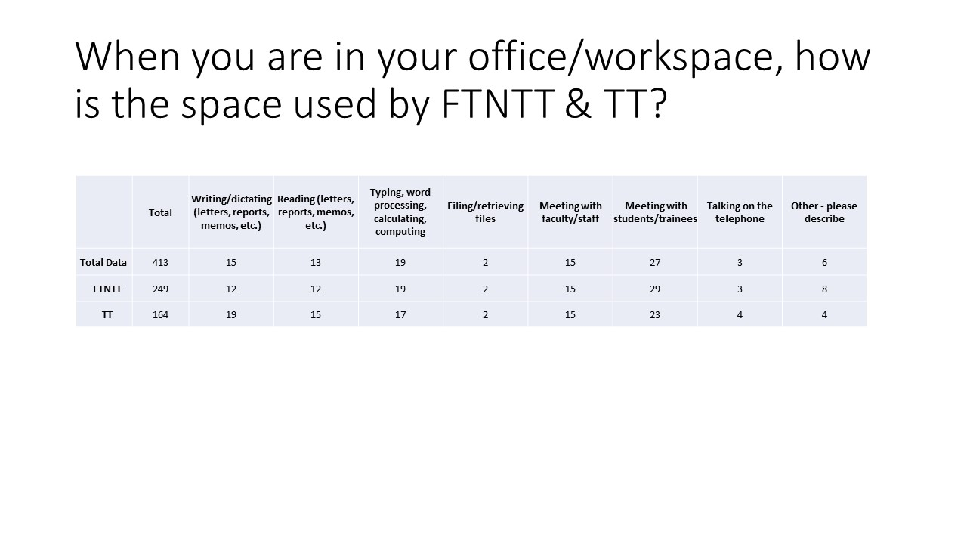

**Table 3: Office space use by campus and by FTNTT and TT**

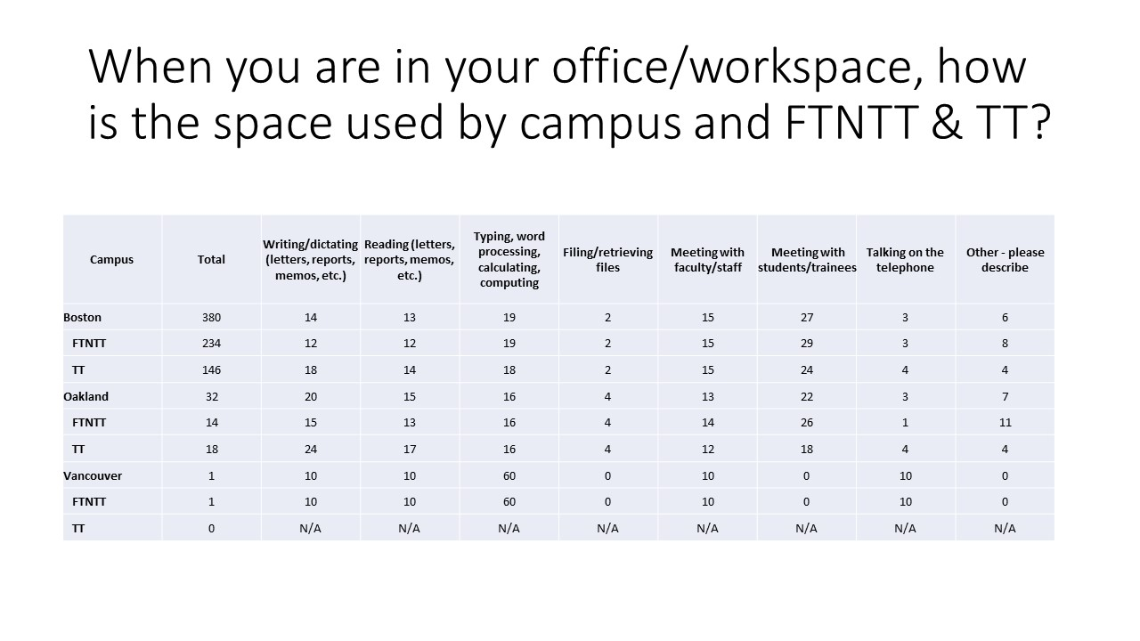

**Table 4: Office space use by position and FTNTT and TT**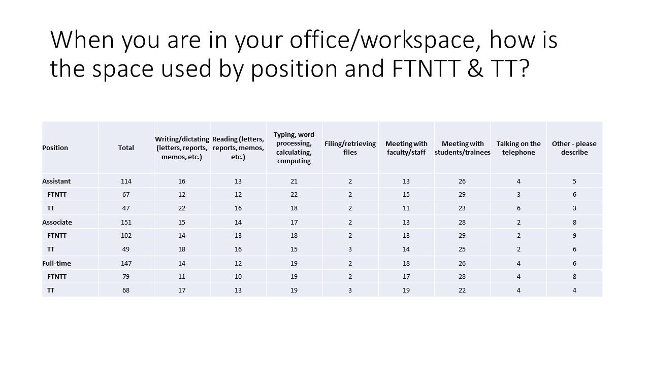

**Recommendations:**

1. Given the high percentage of office space being used for meetings, ensure that faculty have a place for privacy in the event that confidential information is being discussed.
2. Office space usage should be monitored and tracked with any large discrepancies investigated to see if it needs to be addressed further.
3. For further research, shared office space should be split between faculty who are in the room at the same time as others compared to faculty who share offices but on different days and/or times as these categories may lead to differences on how office space is used.

Meeting and storage needs

The committee asked the following questions related to faculty meetings and storage needs. The Excel =Countif and =Countifs functions were utilized to analyze the data.

* How often do you have to schedule meetings in rooms other than your office/work space because your regularly assigned space is too small, inadequately equipped, or insufficient?
* To what extent is visual privacy necessary in your meetings?
* To what extent is acoustical privacy necessary in your meetings?
* Does any of your work require lockable storage?

**Figure 5:**

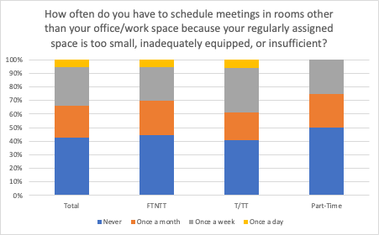

**Figure 5:**

The committee did not find significant differences between T/TT and FTNTT faculty in terms of the frequency with which they have to schedule meetings in rooms other than their own office.

* 57% of all 432 faculty who responded to this question sometimes have to schedule meetings in rooms other than their office/work space because their regularly assigned space is too small, inadequately equipped, or insufficient
* 20% of T/TT and 25% of FTNTT faculty schedule meetings in other rooms once a month
* 33% of T/TT and 25% of FTNTT faculty schedule meetings in other rooms once a week
* .05% of both groups schedule meetings in other rooms on a daily basis.

**Figure 6: To what extent is visual privacy necessary in your meetings?**

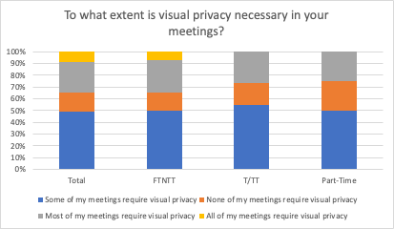

**Figure 6:** The committee did not find significant differences between the 436 T/TT and FTNTT faculty who responded to this question in terms of their need for visual privacy in meetings.

* 54% of T/TT and 50% of FTNTT faculty require visual privacy some of the time
* 27% of T/TT and 26% of FTNTT faculty require visual privacy most of the time
* .07% of T/TT and .08% of FTNTT faculty require visual privacy in their meetings all the time
* 15% of T/TT and 16% of FTNTT do not require visual privacy in their meetings

**Figure 7: To what extent is acoustical privacy necessary in your meetings?**

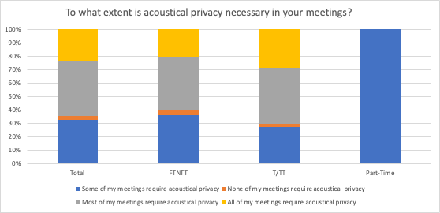

**Figure 7**: The committee did not find significant differences between the 437 T/TT and FTNTT faculty who responded to this question in terms of their need for acoustical privacy in meetings.

* 36% of T/TT and 33% of FTNTT faculty require acoustical privacy some of the time
* 40% of T/TT and 41% of FTNTT faculty require acoustical privacy most of the time
* 20% of T/TT and 24% of FTNTT faculty require acoustical privacy all the time
* .03% of T/TT and .02% of FTNTT do not require visual privacy in their meetings

**Figure 8: Does your office require lockable storage?**

|  |
| --- |
|  |
|  |
|  |

**Figure 8:** Of the 438 total faculty who responded to this question, 58% require lockable storage and 42% do not. When analyzed by T/TT and FTNTT faculty status, we found a significant difference: 50% of FTNTT and 71% of T/TT faculty do work that requires lockable storage

The committee broke these results out by College and identified three Colleges where faculty reported a higher need for lockable storage:

* Bouvé (69%)
* College of Engineering (67%)
* Mills (78%)

Within these three Colleges, a greater percentage of T/TT faculty require lockable storage.

* 83% of T/TT and 62% of FTNTT faculty at Bouvé require lockable storage; 77% of T/TT and 52% of FTNTT faculty at the College of Engineering require lockable storage; and at Mills, 83% of T/TT and 73% of FTNTT require lockable storage.
* The other visually notable difference in FTNTT faculty at CPS is less significant than it appears; 4 total FTNTT faculty in this College responded to this question.

More information is needed; the survey did not ask faculty for specific information about their storage needs, which might include everything from FERPA-protected student materials and paper tests or regulated compounds and materials related to scientific study. Some faculty who answered “yes” to this question may simply require some sort of locker space for their personal items. It may also be that FTNTT faculty are not considering the breadth of materials that they may need storage for.

**Recommendations:**

1. Ensure that adequate workspaces are available for all faculty who need to schedule meetings in spaces other than their office
2. Ensure that all faculty whose work requires it have access to lockable storage
3. For further research: are there an adequate number of workspaces for faculty to use when they need a meeting space other than their office? (ex. Can a faculty member find an office on a day he/she is not normally in the office)?
4. For further research: what specific sorts of lockable storage do faculty need, for what sorts of materials? Do faculty who require it have consistent access to lockable storage?

**Table 5: Distraction in current office/workspace by T/TT vs. FTNTT**

Respondents were asked about distractions in their current office or workspace.

|  |  |  |  |
| --- | --- | --- | --- |
| **Distraction** | **Total** | **FTNTT** | **Tenure/Tenure Track** |
| Machine noise | 5 | 5 | 0 |
| Nearby phone rings/conversations | 3 | 2 | 1 |
| Other conversations | 13 | 5 | 8 |
| General noise | 17 | 11 | 6 |
| Background music | 14 | 10 | 4 |
| Public announcement system | 3 | 1 | 2 |
| Total quietness | 17 | 7 | 10 |
| Printers/Office EQ | 19 | 16 | 3 |
| Personal Radios | 6 | 5 | 1 |

**Table 6**: **Distractions in current office/workspace by campus location**

|  |  |  |  |
| --- | --- | --- | --- |
| **Distraction** | **Bos.** | **Mills.** | **Van.** |
| Machine noise | 6 | 0 | 0 |
| Nearby phone rings/conversations | 61 | 3 | 0 |
| Other conversations | 13 | 0 | 0 |
| General noise | 28 | 3 | 0 |
| Background music | 2 | 1 | 0 |
| Public announcement system | 2 | 0 | 0 |
| Total quietness | 3 | 0 | 0 |
| Printers/Office EQ | 22 | 0 | 0 |
| Personal Radios | 6 | 0 | 0 |

**Table 7: Distractions by College**

|  |  |  |  |  |  |  |  |  |  |  |
| --- | --- | --- | --- | --- | --- | --- | --- | --- | --- | --- |
| **Distraction** | **Bouvé** | **CAMD** | **Khoury** | **COE** | **CPS** | **COS** | **CSSH** | **DMSB** | **Mills@NU** | **Law** |
| Machine noise | 0 | 2 | 2 | 0 | 0 | 1 | 0 | 0 | 0 | 0 |
| Nearby phone/conv. | 1 | 0 | 0 | 0 | 0 | 0 | 0 | 1 | 0 | 0 |
| Other conv. | 19 | 33 | 42 |  | 0 | 8 | 13 | 8 | 1 | 1 |
| General noise | 4 | 2 | 3 | 1 | 1 | 9 | 4 | 5 | 2 | 1 |
| Background music | 0 | 0 | 0 | 1 | 0 | 1 | 0 | 0 | 1 | 0 |
| Public announcement system | 1 | 0 | 0 | 1 | 0 | 0 | 0 | 0 | 0 | 0 |
| Total quiet. | 0 | 0 | 1 | 1 | 1 | 0 | 0 | 0 | 0 | 0 |
| Printers/Office EQ | 2 | 2 | 0 | 4 | 0 | 5 | 1 | 7 | 0 | 1 |
| Personal Radios | 0 | 2 | 0 | 1 | 0 | 1 | 1 | 1 | 0 | 0 |

**Table 8: Other distractions by location**

|  |  |  |
| --- | --- | --- |
| **Other distractions by location** | **Boston** | **Mills** |
| Office temperature | 8 | 1 |
| Hallway traffic/noise | 16 | 1 |
| Music | 3 | 0 |
| HVAC | 7 | 0 |
| Landscaping/Construction | 6 | 1 |
| Mold/Mildew | 3 | 0 |
| Street noise | 9 | 0 |

**Summary of Tables 5-8 covering distractions:**

While faculty of all ranks noted some distractions in their work/office space, the most common distractions include general noise, (hallway) conversations, and printer/office equipment. FTNTT Faculty, especially in the Colleges of Bouvé, CAMD, Science, CSSH, and D’Amore-McKim, are disproportionally affected (nearly 2:1) compared to their T/TT colleagues. This may be the result of a general lack of private office space requiring many FTNTT faculty to work in more “public,” shared places.

**Recommendation:**

1. Reassess office space availability, especially on the Boston campus, and prioritize providing offices/workspaces that are more private and, therefore, conducive to concentration and productivity.

University-provided Computer and is Adequate for your Needs?

Respondents were asked whether the university provides them with a work computer and whether the computer provided meets their work needs?.

**Table 9: University-provided computer by Job Status**

|  |  |  |
| --- | --- | --- |
| **Rank** | **Yes** | **No** |
| FTNTT | 243 | 31 |
| T/TT | 116 | 16 |

**Table 10: University-provided computer by Location**

|  |  |  |
| --- | --- | --- |
| **Location** | **Yes** | **No** |
| Boston | 211 | 26 |
| Charlotte | 1 | 0 |
| Mills | 12 | 0 |
| Portland | 2 | 1 |
| Seattle | 4 | 2 |
| SV | 2 | 0 |
| Toronto | 2 | 0 |
| Van. | 5 | 2 |
| Arl. | 4 | 0 |

**Table 11: University-provided computer by College**

|  |  |  |
| --- | --- | --- |
| **College** | **Yes** | **No** |
| Bouvé | 44 | 6 |
| CAMD | 50 | 11 |
| Khoury | 27 | 10 |
| Engineering | 33 | 6 |
| CPS | 27 | 0 |
| Science | 62 | 12 |
| CSSH | 59 | 4 |
| D’More-McKim | 48 | 1 |
| Mills | 19 | 0 |
| Law | 6 | 0 |

**Table 12: Is Your University-provided Computer Adequate to Complete your Work?**

|  |  |  |
| --- | --- | --- |
| **Rank** | **Yes** | **No** |
| FTNTT | 216 | 26 |
| T/TT | 104 | 12 |

**Table 13: “Is it Adequate” by location**

|  |  |  |
| --- | --- | --- |
| **Location** | **Yes** | **No** |
| Boston | 278 | 36 (23 FTNTT) |
| Mills | 24 | 2 |
| Seattle | 2 | 2 |

**Table 14: “Is it Adequate?” by College**

|  |  |  |
| --- | --- | --- |
| **College** | **Yes** | **No** |
| Bouvé | 39 | 7 |
| CAMD | 5 | 0 |
| Khoury | 23 | 0 |
| Engineering | 27 | 4 |
| CPS | 23 | 0 |
| Science | 57 | 2 |
| CSSH | 48 | 6 |
| D’Amore-McKim | 38 | 7 |
| Mills | 17 | 1 |
| Law | 5 | 0 |

**Table 15:** **“Is it Adequate?” by T/TT vs. FTNTT by College**

|  |  |  |  |
| --- | --- | --- | --- |
| **College** | **Rank** | **Yes** | **No** |
| Bouvé | T/TT | 6 | 2 |
| FTNTT | 30 | 5 |
| CAMD | T/TT | 19 | 4 |
| FTNTT | 24 | 3 |
| Khoury | T/TT | 3 | 0 |
| FTNTT | 15 | 0 |
| Engineering | T/TT | 5 | 0 |
| FTNTT | 15 | 0 |
| CPS | T/TT | 1 | 0 |
| FTNTT | 22 | 3 |
| Science | T/TT | 18 | 1 |
| FTNTT | 39 | 1 |
| CSSH | T/TT | 19 | 4 |
| FTNTT | 30 | 2 |
| D’Amore-McKim | T/TT | 11 | 1 |
| FTNTT | 27 | 6 |
| Mills | T/TT | 11 | 0 |
| FTNTT | 6 | 0 |
| Law | T/TT | 2 | 0 |
| FTNTT | 3 | 0 |

**Summary**:

* Most faculty, regardless of rank, have a University-provided computer and feel it's adequate to complete their work.
* However, 17% of mostly non-tenure track faculty in Bouvé and D'Amore-McKim report their computer is inadequate to complete their work.

**Recommendations:**

1. The university should continue with this practice of ensuring all faculty are provided with a computer.
2. The university should ensure that information about university-provided computers is provided regularly and consistently.
3. The university should survey FTNTT faculty in Bouvé and D'Amore-McKim about their computer needs.

Computer Replacement

As part of the Fall ‘23 Faculty Survey we asked participants how often they have their computers replaced by their IT departments.

**Figure 9: How often is your computer replaced?**

**Figure 10: How often is your computer replaced? “Other responses:**

**Summary:​**

* Most respondents have their computers replaced every 3-5 years (28%), they have a need-based replacement option (29%), or do not know what their replacement schedule is (14%).
* When broken down between T/TT and FTNTT Faculty we found that:
* FTNTT Faculty are more likely to report that they do not know what their replacement policy is by a margin of 4:1​
* FTNTT Faculty reported that their machines are only replaced when they become unusable at a rate of 42% compared to 30% of T/TT Faculty
* When looking at frequency of replacement 40% of T/TT Faculty report having their computer replaced every 2-3 years compared to 19% of FTNTT Faculty
* 11% of T/TT Faculty report that their computers are replaced every 4-5 years compared to 25% of FTNTT Faculty

**Recommendation:** ​

1. College-level IT departments need to have a defined policy on computer replacement and make sure it is communicated to all Faculty.
2. T/TT Faculty are more likely to be knowledgeable about their replacement options so this information needs to be communicated to all Faculty in the same manner regardless of whether they are T/TT or FTNTT.
3. Faculty need to be more proactive about finding out their replacement options when needed. ​

**Faculty titles**

* Appendix D of the 2021-2022 FTNTTFS Report summarizes the most common titles at Northeastern.

**Recommendation:**

1. Since the integration of Mills College and Northeastern University at London, a future committee should expand the list of current titles and how they can be merged in with the 4 major titles, as was recommended by the 2022-2023 FTNTTSC.

**Evaluation and advancement process and criteria**

* Charge 1 of the 2021-2022 FTNTTFS Committee addressed the evaluation and advancement process and criteria.

**Recommendation:**

1. A future FTNTTFS Committee investigate the whether resolutions from charge 1 have been implemented. Refer to 2021-2022 final report for resolutions related to this charge.

**Tenure**

* As inherent with our job category, none of us are eligible for tenure.
* In 2021, WPI adopted a policy to convert teaching faculty to tenure-track (<https://www.wpi.edu/sites/default/files/faculty-governance/SummaryofOurWork-September12021.pdf>)

**Recommendation:**

1. A future FTNTTFS Committee investigate whether conversion of full-time non-tenure track faculty to a tenure-track faculty is possible at Northeastern University

**Resolutions:**

**Whereas** the FTNTT Committee has made the following recommendations:

1. All faculty holding a second rank or higher and holding their position at Northeastern for at least 6 years regardless of funding mechanism for salary support be eligible for sabbatical so this policy aligns with the One Faculty model.

2. Regardless of office space accommodations on campus, private space be available to be reserved for meetings requiring auditory and/or visual privacy.

3. That all Faculty regardless of rank or tenure status should be provided a computer at the start of their employment. This computer should be replaced every three years or when the warranty expires, whichever is sooner. HR will make this policy available to all new employees during their onboarding.

 4. That CAMD’s Faculty Development Funding Policy and related communication strategies be adapted and implemented across all colleges to ensure that funding for professional development, and research and teaching opportunities are being fairly communicated to all Faculty regardless of rank or tenure status.

5. That since office activities don’t vary when analyzed by college, location, rank, and faculty-type, office space accommodations with lockable storage on campus be the same for faculty affiliated with a college and at a location regardless faculty-type.

6. That all job postings contain realistic salary ranges (see Seattle campus data below) regardless of campus location.

**Therefore be it resolved** that the Senate Agenda Committee shall work with the Provost’s Office to investigate the feasibility of adopting these recommendations and report to the Senate by January 2025.

1. Undertake an examination of any available NU FTNTT salary comparison data, currently posted NU FTNTT salary ranges, and NU TT/T salary ranges to recommend salary ranges for FTNTT faculty.

**Activities Undertaken to Address Charge:**

* The committee reviewed posted job descriptions and spoke with the Sr. Vice Provost Academic Affairs.
* From October 2023 to February2024, any posted salary information was retrieved for the committee to use in the analysis and recommendations.
  + The minimum and maximum salaries were graphed to obtain an estimated average salary. These values were plotted based on location, college, type (NTT vs T/TT), and rank (Assistant vs Associate vs Full).
* In the discussion with the Sr. Vice Provost Academic Affairs in the fall, it was stated that salary information would not be provided (see Salary section of Charge 1).

In the Faculty Senate Spring Survey, salary questions were submitted. The committee was not provided with the survey results and therefore could not review nor analyze the Spring Survey data.

**Summary:**

* A total of 35 unique job descriptions were reviewed with multiple positions divided by position (ex. Split by assistant, associate, senior, and/or open rank).
* Only campuses located in California, Washington, and Canada showed salary information on the job descriptions.
* All other locations (ex. Boston) do not have salary information in the job description. However, there is some data for those positions, but they came about by specifically asking the hiring managers for this information.
* For salary information provided, some ranges were quite large as multiple job levels were shown (ex. Assistant, Associate, Senior, Open Rank). The differences in ranges were as small as $14,900 to as large as $136,000.
* This is for campuses located in the U.S. and the salary information was posted. For Canadian campuses that posted salary data, the differences in salary ranges are smaller CAD $23,340 to CAD $44,565.

**Recommendation:**

1. The Committee recommends that salary ranges be added to all job descriptions across all campuses.
2. In conjunction with the Provost’s Office and the Vice Provost of Data & Analytics, salary ranges should be reviewed every 2 years to ensure that salary ranges are relatively equal based on cost of living by campus, rank, and FTNTT & T/TT positions.
3. Add salary questions to the annual Faculty Senate Survey to document and resolve disparities among faculty.
4. College equity data be made available to all faculty regardless of college affiliation and/or made available to senate committees for analysis purposes.

**Resolution:**

1. Be it resolved that all job postings contain realistic salary ranges (see Seattle campus data below) regardless of campus location.

|  |
| --- |
|  |
|  |
| **Figure 1 Estimated Faculty Averages Based on Available Job Postings:** A) Estimated Average Salary of Oakland Faculty broken down by College, Rank, and Faculty type. B) Estimated Average Salary of Seattle Faculty broken down by College, Rank, and Faculty type. |

1. In collaboration with the Faculty Development Committee, lead the effort to substantiate and document the disparity in the recruitment of, and working conditions experienced by, FTNTT faculty

**Activities Undertaken to Address Charge:**

* The FTNTT committee forwarded the data and the draft report to the Faculty Development Committee and has kept the committee updated with any status changes.
* Any disparities in working conditions have already been documented in charge 1.
* Recruitment discrepancies were limited to reviewing the salary information (see charges 1 & 2).
* The Faculty Development Committee sent the draft information to this committee.

**Recommendations:**

1. The two committees continue to collaborate to substantiate and document any disparities in the recruitment of, and working conditions experienced by FTNTT.
2. Analyze how candidates are recruited such as where positions are posted to attract candidates.

Respectfully submitted,

John Bleakney, COE (Co-Chair)

Erica P. Homan, COS (Co-Chair)

Isabel Dmitruk, CAMD

Lori Ferrins, COS

Brent Griffin, CPS

Sarah Woodside, DMSB

Stephanie Young, Mills