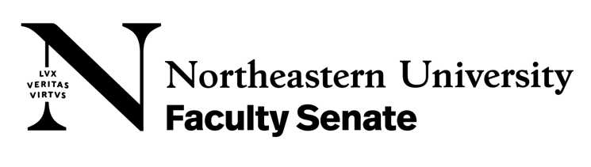
TO: Senate Agenda Committee
FROM: Faculty Development Committee
DATE: March 6, 2024
SUBJECT: Final report for 2024

The Faculty Development Committee had 9 meetings during the academic year. The committee carried out the specific charges assigned by SAC. The charges were addressed as follows with recommendations and/or resolutions:

Charge 1 in 3 sub-charges
As recommended by the 2022-23 FDC Committee, the 2023-24 FDC shall:
- Support the 2023-24 FTNTT Faculty Committee in substantiating and documenting the disparity in the recruitment of, and working conditions experienced by, FTNTT faculty.
- Document the degree to which cross-appointed tenure-line faculty contribute effectively to shared governance.
- Regarding faculty on Northeastern’s global campuses, clarify:
  - How they are represented in the Faculty Senate
  - What opportunities they have to participate in shared governance
  - What opportunities they have to provide meaningful feedback to the institution

Charge 1a: Representatives from the FDC and FTNTT met more than once to triangulate work and overlapping charges. The committees decided to focus the work on specific charges each committee oversees and share the information.

Charge 1b: Questions regarding this are addressed by the FTNTT committee survey questions to some degree.

Charge 1c: The FDC is still working on this charge. We intend to evaluate the Faculty Senate’s committee assignments to evaluate committee placement regarding home campus faculty.

Charge 2 in 4 sub-charges
Informed by data collected in the 2022–23 FDC Final Report, undertake the following:
- Survey faculty to understand their perception of the effectiveness of communications and opportunities for feedback within their College and the University at large.
- Collaborate with the Ombuds Office to survey the extent to which the lack of effective communications might contribute to faculty disenfranchisement.
- Develop recommendations for how all Colleges might schedule regular outbound communications on topics related to faculty development and shared governance.
- Develop recommendations for how all Colleges might establish formal methods of inbound communications, including anonymized methods, to solicit feedback, concerns, and ideas from the faculty. Considerations should include how faculty can be regularly reminded of these available methods and resources via the Ombuds Office.

Charge 2a: We wrote 6 questions that were included in the Fall Faculty Survey (Q20–25). Our analyses of the data collected via this instrument follow.

Question 20: The Faculty Development Committee has been tasked with understanding the effectiveness of communications and opportunities for feedback at Northeastern. Please rate the extent to which you agree with the following statements:

- I receive timely and relevant information from my unit head.
- I receive timely and relevant information from my Deans Office.
- I receive timely and relevant information from Northeastern upper administration.
- I receive timely and relevant communications about faculty development and shared governance from my unit head.
- I receive timely and relevant communications about faculty development and shared governance from my Deans Office.
- I receive timely and relevant communications about faculty development and shared governance from Northeastern upper administration.
- I know how to provide feedback, concerns, and/or input to my unit head.
- I know how to provide feedback, concerns, and/or input to my Deans Office.
- I know how to provide feedback, concerns, and/or input to Northeastern upper administration.
- I am comfortable providing feedback, concerns, and/or input to my unit head.
- I am comfortable providing feedback, concerns, and/or input to my Deans Office.
- I am comfortable providing feedback, concerns, and/or input to Northeastern upper administration.

Analysis: These Likert-scaled statements are meant to measure faculty members’ impression of the communications they receive from (statements A–F), and their opportunities for and comfort providing feedback to (statements G–L), Northeastern at three hierarchically different administrative levels: their unit (statements A, D, G, and J), their College (statements B, E, H, and K), and University upper administration (statements C, F, I, and L). The data summarized in the stacked bar graph below represent all responses; there was little meaningful difference when isolating responses by faculty type (NTT vs. TT/T), rank (assistant, associate, full, and equivalents), or campus (Boston vs. non-Boston).

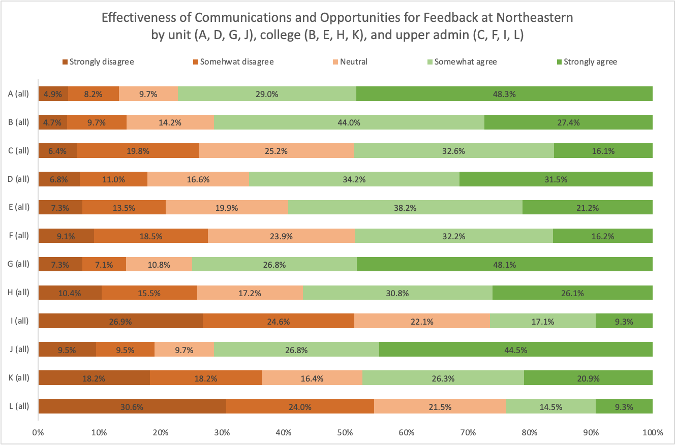
The data show that, in general, respondents feel more confident in the communications they receive from, and the feedback they provide to, progressively more local administrative levels. That is, a comparison of respondents’ ratings shows a more favorable perception of communications with their unit head (statements A, D, G, and J), a less favorable perception of communications with their Deans Offices (statements B, E, H, and K), and a generally unfavorable perception of communications with Northeastern’s upper administration (statements C, F, I, and L). The biggest disparity can be seen in the responses to the statements measuring respondents’ awareness of how to provide feedback (statements G–I). At the level of the individual unit, 74.9% either somewhat or strongly agree that they know how to provide feedback to their unit head (statement G), while 14.4% either somewhat or strongly disagreed, a difference of over 60 percentage points. In contrast, only 26.4% of respondents either somewhat or strongly agree that they know how to provide feedback to the upper administration (statement I), while 51.5% either somewhat or strongly disagreed, a difference of 25 percentage points.

Another take-away from these data involves disparities between receiving information vs. providing feedback or input. While scores for outbound and inbound communications at the unit level compare favorably, the data show that respondents perceive outbound communication channels to be more effective than inbound communications channels at the College and University levels. Overall, these data suggest that different strategies will be needed to improve communications between faculty and administration at the different hierarchical levels measured, and that Deans Office and upper administration representatives need to make a concerted effort at facilitating meaningful opportunities for faculty to provide feedback, concerns, and input.

Question 21: In what ways and/or to whom have you provided feedback, concerns, and/or input?

Analysis: The most common method for faculty to receive feedback, concerns, and/or input is from their unit head or Program Director. After that other communication commonly comes down from the Dean’s office and the Faculty Senate. Most respondents noted that they receive communications from more than one source. Other ways that were entered by responding faculty included specific committees, the Provost office, and from peers.

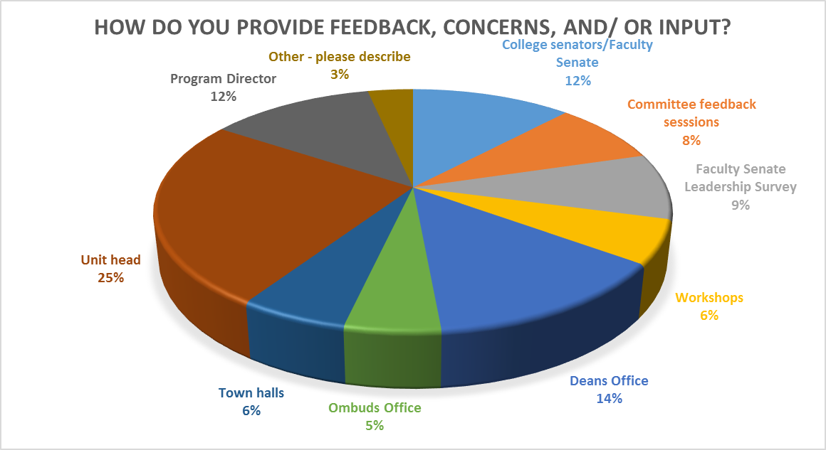

Question 22: Through what communications channels, including anonymized methods, would you prefer to provide feedback and/or input to Northeastern?

Analysis: A general call for anonymized methods was the most common response to this question including a generic email, surveys, and ombuds. Another trend in the responses was that faculty felt that the methods were sufficient but that there is no action or response for the feedback. This was detailed as either a lack of communication or action from the senior leadership, specifically the Provost’s office. Face-to-face, in-person, and focus groups are the most common non-anonymized responses.

Question 23: How often would you prefer to receive communications from your Deans Office about topics relevant to faculty?

Analysis: The majority of respondents preferred to receive weekly emails from the Dean’s office of their College about topics relevant to faculty development/shared governance. This was followed by monthly communication (38%) and quarterly/annually frequency was under 6%. “Other- please describe” respondents totaled 27 votes or 5.7% ranged from “as appropriate”, “it depends”, and “bi-weekly” options.

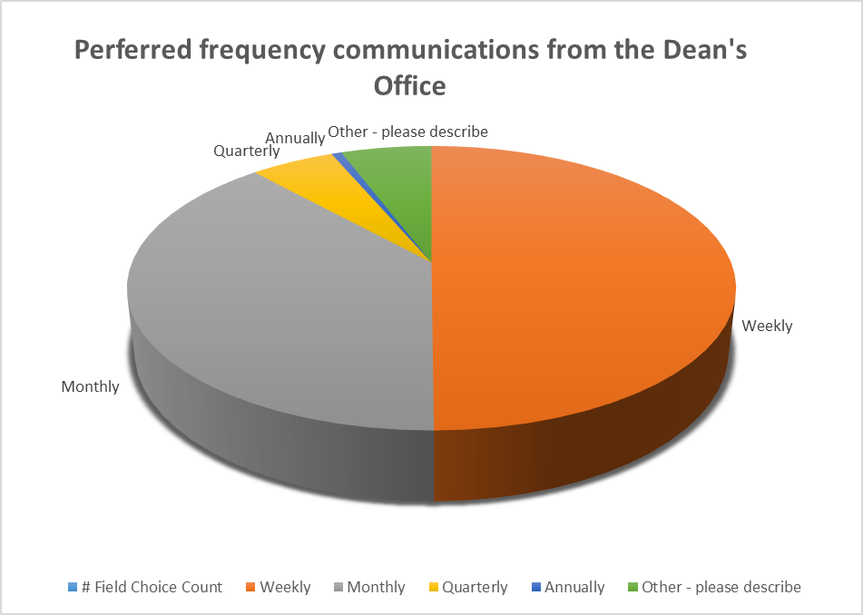

Question 24: Through what channels would you prefer to receive communications on topics related to faculty development and/or shared governance?

Analysis: The majority of respondents chose email as their primary channel to receive communication related to faculty development and/or shared governance (76%). The next closest options were town hall meetings and newsletters each receiving 3% of the vote.

Question 25: What are your biggest concerns or questions about communications at Northeastern?

Analysis: Faculty mentioned some extensive comments regarding concerns with communication. Four areas of the themes of the comments included: 1) too many emails/communications; communication is bidirectional and more listening is needed, 2) major initiatives are announced without faculty input feeling very “Top Down”, 3) timeliness of communication with not enough time to react before decisions/actions are required, and 4) reasoning and transparency behind decision making is lacking.

Additional comments that were frequently noted included these thematic areas: global campus communications are infrequent and lacking infrastructure, bureaucracy in information filtering is noticeable, nothing will change so not responding/fear of retaliation, feeling isolated, hard to find policies and information and action from feedback is lacking.

Top areas of comments
To many emails/communications
Communicaton should be bidirectional, more listening is what is needed
Major initiatives are often announced without faculty input, “top down”
Timeliness of communication with not enough time to react before decisions/actions are required
Reasoning and transparency behind decision making is unclear
Frequent area of comments
Global campus communications are infrequent, lacking infrastructure
Bureaucracy in information filtering down
Nothing will change so not responding & fear of retaliation
Feel isolated in my unit
Hard to find policies and information
Action from feedback lacking
No comment/no concern

Charge 2b: FDC co-chair Andrew Mall emailed and met with Diane Levin in the Ombuds Office. Due to the confidential nature of reports made to her office, Ombuds Levin could only provide information on general trends she noted. Nonetheless, several themes emerged related to charge 2b:
- Collaboration (or lack thereof) between upper administration and faculty: Faculty perceive that communication from senior leadership worsened during the COVID pandemic and has not wholly improved. In 2020 there was a sense among faculty that they were being kept “in the dark,” and that upper administration and senior leadership were making decisions without meaningful input from faculty, particularly our most vulnerable populations. Even though the University is no longer in an emergency response mode, this sense of unilateral or top-down decision making persists among faculty, suggesting that this is a more entrenched issue not caused by the COVID pandemic but rather revealed by it.
- This problem is replicated at more local administrative levels: Faculty report that unilateral or top-down decision making with little transparency and few meaningful opportunities to provide input are increasingly the norm in their Deans Offices and units. Communication is a trust-building tool when wielded effectively and appropriately; trust is thus a by-product of good communications and a casualty of poor communications. Faculty are losing trust in their leadership. Furthermore, leadership turnover worsens these already-challenging relationships. Although faculty report being more comfortable communicating with their unit heads than with their Deans Offices or upper administration (see data provided for Charge 2a Question 20, above), unit heads would benefit from more training to address issues of equity and diversity and to navigate complex interpersonal dynamics among faculty colleagues. Particularly within units, where colleagues interact with each other regularly, those interactions accumulate over time and “acquire a gravitational pull”; it is imperative that these interactions set a positive tone for the work environment.
- Optimizing for student outcomes at the expense of faculty buy-in: There is a perception among faculty that Northeastern approaches its educational mission as selling a product to student-customers, and in doing so upper administration neglect faculty members’ commitment and expertise. Although this tension speaks more to mission alignment between the institution and individual faculty than it does to communications problems, certainly a more transparent and open communications style could help alleviate this issue.
- Faculty need clarity about their working conditions: Many faculty report not knowing or being confused about what resources are available to support them, both in terms of their work and their employee benefits. Several faculty have reported environmentally hazardous working spaces with little or no satisfactory resolution. Faculty on eight-month contracts need very clear expectations about the extent to which they are expected to work on behalf of Northeastern outside of their eight months of compensation.

Charge 2c: Faculty survey data was analyzed, and the following recommendations are suggested to address how Colleges might schedule regular outbound communications on topics related to faculty development and shared governance.

Recommendations:
- Based on faculty preference and survey data, the FDC recommends bimonthly or monthly emails from the Dean’s office to provide outbound communication on topics related to faculty development and shared governance.
- It is recommended that a college-wide email list be generated controlled by the Faculty Senate to disseminate relevant communications, providing a direct line of communication between them and faculty.

Charge 2d: Faculty survey data was analyzed, and the following recommendations are suggested to address how colleges might establish formal methods of inbound communications.

Recommendations:
- The Faculty Senate should organize anonymized feedback options via multiple methods (emails, surveys, etc) that provide input across the different hierarchically administrative levels (Unit, College, & Upper administration).
- The Faculty Senate should ensure all inbound anonymous feedback is accessible to each College’s Senators to improve communications between faculty and administration as well as address faculty frustrations of poor bidirectional communications and lack of administration action in response to feedback.
- There is a strong need for more transparency, accountability, and evidence that feedback is being heard and addressed, particularly by the Provost Office.

Charge 3
In response to the 2022-23 FDC’s recommendations for providing faculty development in order to better support students with combined majors, the 2023-24 FDC Charge 3 shall investigate whether any of the six recommendations for addressing issues related to students with combined majors put forth in the 2022-23 FDC Final Report appear to be in effect. Identify which have not been adopted, and if not, discuss potential paths forward for implementation, and/or possible challenges to implementation. For any which have been adopted, briefly assess their status.

- For charge 3, our first step has been to determine how and when, if at all, the recommendations for addressing issues related to students with combined majors put forth in the 2022–23 FDC Final Report were communicated to the relevant administrative units (Provost Office, CATLR, Deans Offices). Our understanding from our SAC liaison is that Resolutions that emerge from committee final reports are formally communicated to the Provost Office and other administrative units for implementation, but that there appears to be little formal mechanism for recommendations that do not rise to the level of Resolutions to be similarly communicated. We cannot study the extent to which any of these recommendations have been adopted if the responsible administrative units have not been made aware of these recommendations.
- To (partially) remedy this situation, we are in the process of drafting communications to Deans Offices that will include:
  - The relevant recommendations referenced above
  - Findings from the 2023–24 FDC questions related to communications (in line with Charge 2)

Recommendations:
- The Faculty Senate should ensure that the 2022–23 FDC recommendations are communicated to the Provost Office.
- The Faculty Senate should charge the 2024–25 FDC with following up on these communications (to the Provost Office and Deans Offices) to make further progress on this charge.
- The Faculty Senate should
  - Establish formal mechanisms by which committees’ recommendations are communicated to the relevant administrative units within Northeastern, in addition to existing mechanisms for Resolutions.
  - Provide committees with clear guidance as to determining which recommendations should be elevated to Resolutions.

Respectfully submitted,
Andrew Mall, Co-Chair (CAMD)
Andrew Orr-Skirvin, Co-Chair (BCHS)
Needa Brown (COS)
Mario Hernandez (Mills)
Mark Sivak (CAMD/COE)

